November-December 2016

Heathery Knowe Nursery Happenings !

The children have now finished their topic Under the Sea. The children have really enjoyed learning about this topic at nursery and at home. All of the staff have been amazed at the wonderful knowledge and information the children have brought from home to share with their friends in nursery.

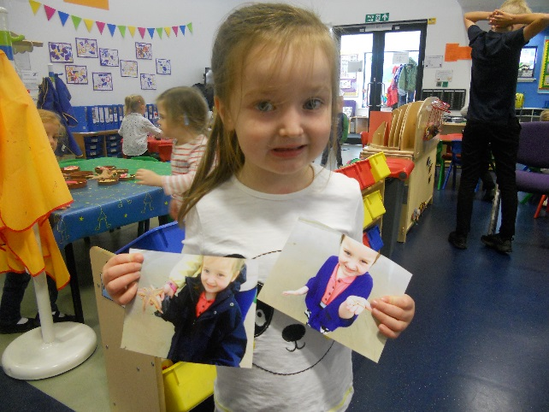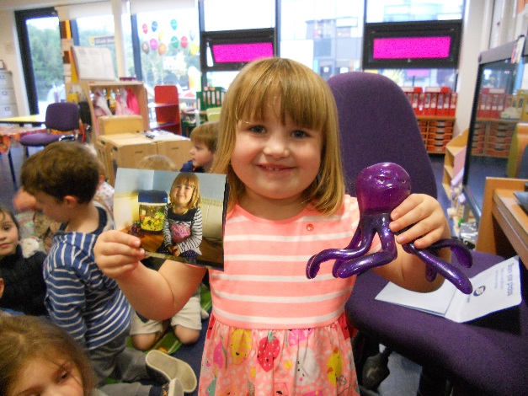

Please take a few moments to look at all the learning and experiences your child was part of during this topic in the Big Book in the nursery entrance. There is a page at the beginning of the Big Books to write a comment!

The children will now be learning about money as part of Heathery Knowe Money Week. As an enterprise activity during this mini topic, children will be creating crafts and a hamper to sell in nursery.

C:\Program Files\Microsoft Office\MEDIA\CAGCAT10\j0183290.wmf

Following on from this mini topic children will begin to learn more about Christmas and the Nativity Story. The children will be mind-mapping what they know about Christmas and the Nativity story and we are excited to see where the children’s ideas will take us in our learning!

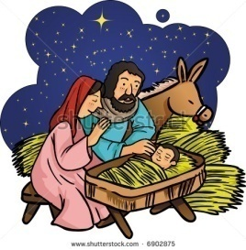

We will also begin our Nativity rehearsals. Some children may be given words to learn at home with their parents/carers. We would appreciate your support in helping your child learn their words.

Christmas

As we went to Low Parks last year, we have arranged for Sticky Kids to come into nursery, to perform their interactive Christmas Show for the children.

We also feel that it would be lovely to get all the children and staff together for this Christmas Party.

The Christmas Party will be held on Wednesday 7th November in the morning only. All children should be dropped off at nursery at 8.45am and collected at 11.45am. Due to all children being in for the morning session there will be no afternoon nursery session on Wednesday 7th November.

Parents/carers are invited to return to nursery at 11.00am to watch their child meet Santa. Please use the school entrance as the children will be meeting Santa in the school gym hall.

Christmas Party Itinerary

8.45am-9.00am: Children dropped off at nursery

9.00am-9.30am: Christmas Crafts

9.30am-10.30am: Sticky Kids Christmas Show

10.30am-11.00am: Christmas Snack

11.00am-11.45am: Meeting Santa (with parents/carers)

11.45am-11.55am: Children collected from nursery

**Upcoming events**

* Thursday 8th November – Photographs
* Friday 18th November – Dotty Day
* Monday 21st November – In-service day (nursery closed)
* Wednesday 30th November – Children’s Christmas craft sale in nursery
* Friday 2nd December – Christmas Fair
* Wednesday 7th December – Christmas Party with Sticky Kids and Santa! (All children to attend AM session, there is no PM session today)
* Monday 20th December – Nativity(AM held at 10.00am and PM held at 1.45pm).
* Thursday 22nd December – School and Nursery closes at 2.30pm
* Monday 9th January – School and Nursery opens.